Call for Papers Instructions
TNOTA’s Virtual Conference 2020

Call for papers submissions are due by July 1, 2020.

For our 2020 virtual conference, TNOTA is partnering with True Approve, a new CE management software, to digitally manage our conference submissions for the 2020 TNOTA Conference. Below are some instructions to assist you through this new process.

You will be required to register for a True Approve account to communicate with the conference committee throughout this process.

https://trueapprove.dabrinteractive.com/Register/TNOTA

When creating an account, in the drop-down menu "Provider Type", you MUST select Conference Presenter.

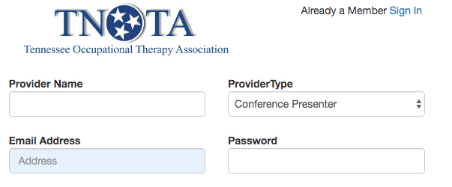

After you have created an account follow these steps:
- Login to True Approve
- Click “My Presentations” on the left side of screen
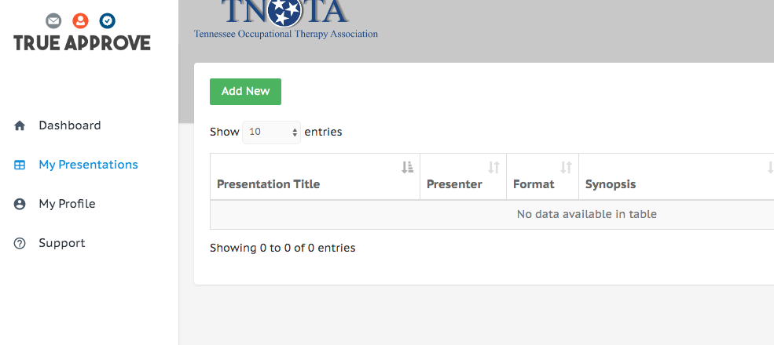
- Select “Add New”

- This form must be filled out completely. (Incomplete forms will not be processed.)
- You can add multiple presenters, but the person who fills out the registration will be the primary contact.
- You must complete the “TNOTA Conference 2020 Presentation Submission” document and submit it with your True Approve Application using the “upload attachment” link. This document can be downloaded from the TNOTA website. The word doc will have to be converted to a pdf prior to uploading to True Approve.

You will be notified via email if TNOTA requires additional information and when your presentation is approved or denied for TNOTA Conference 2020. Notifications will be sent out by mid- July 2020.

To convert word doc to pdf, follow the instructions below, or you can search Google or YouTube for instructional videos.

How do you convert a Word Document to a PDF?
- Click the Microsoft Office Button, point to the arrow next to Save As, and then click PDF or XPS.
- In the File Name list, type or select a name for the document.
- In the Save as type list, click PDF.
- If you want to open the file immediately after saving it, select the Open file after publishing check box.
- Click Publish.

