Coverage for Telehealth Services In Tennessee
**This information was gathered through an effort of TNOTA’s advocacy team. It is current, to the best of our knowledge, as of April 30, 2020. ***
Traditional Medicare (part A and B)
- Effective April 30, 2020, the Centers for Medicare and Medicaid Services (CMS) determined that occupational therapists will be allowed to perform telehealth services for Medicare beneficiaries during the COVID-19 health crisis. Initially, occupational therapy services were not covered under the CARES Act but through the tireless efforts of advocates this is no longer the case. Telehealth services can be billed using the list of CPT codes CMS issued on March 30, 2020. AOTA is continuing to advocate for occupational therapy assistants to provide telehealth services during this time. For more information, refer to the resources listed below. The main modification is in regard to the section 1834(m)(4)(E) of the Act and 42 CFR § 410.78 (b)(2) which expands the types of practitioners who can provide telehealth services from a remote site such as physical therapists and speech language pathologists.

https://www.cms.gov/files/document/summary-covid-19-emergency-declaration-waivers.pdf
https://www.aota.org/Advocacy-Policy/Federal-Reg-Affairs/News/2020/Medicare-Telehealth-Success.aspx?promo_name=cms-tele-apr&promo_creative=Advocacy-Policy&promo_position=hero

Download the list of covered codes at https://www.cms.gov/Medicare/Medicare-General-Information/Telehealth/Telehealth-Codes

Covered OT codes include:
97165 | Ot eval low complex 30 min | Temporary Addition for the PHE for the COVID-19 Pandemic
97166 | Ot eval mod complex 45 min | Temporary Addition for the PHE for the COVID-19 Pandemic
97167 | Ot eval high complex 60 min | Temporary Addition for the PHE for the COVID-19 Pandemic
97168 | Ot re-eval est plan care | Temporary Addition for the PHE for the COVID-19 Pandemic
97530 | Therapeutic activities | Temporary Addition for the PHE for the COVID-19 Pandemic—Added 4/30/20
97535 | Self care mngment training | Temporary Addition for the PHE for the COVID-19 Pandemic
97542 | Wheelchair mngment training | Temporary Addition for the PHE for the COVID-19 Pandemic—Added 4/30/20
97750 | Physical performance test | Temporary Addition for the PHE for the COVID-19 Pandemic
97755 | Assistive technology assess | Temporary Addition for the PHE for the COVID-19 Pandemic
97760 | Orthotic mgmt&traing 1st enc | Temporary Addition for the PHE for the COVID-19 Pandemic
97761 | Prosthetic traing 1st enc | Temporary Addition for the PHE for the COVID-19 Pandemic

United Health Care
The following codes are covered for telehealth, through June 18, 2020.
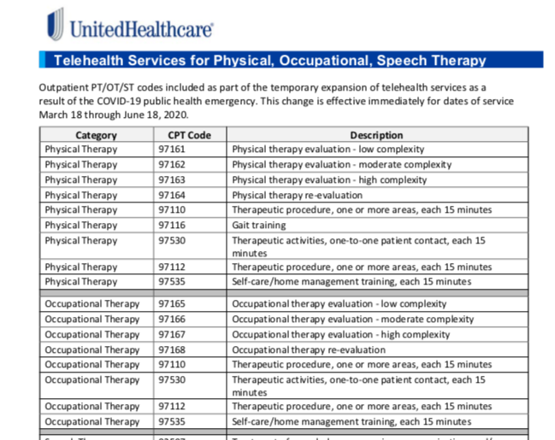

Information obtained from https://www.uhcprovider.com/en/resource-library/news/Novel-Coronavirus-COVID-19/covid19-telehealth-services.html

Contact UHC

Aetna:
For the next 90 days (written on March 17, 2020), Aetna will cover minor acute evaluation and management services rendered via telephone. A visual connection is not required. For general medicine and behavioral health visits – a synchronous audiovisual connection is still required. Aetna’s telemedicine policy is available to providers on the NaviNet and Availity portals.

Codes covered by these changes appropriate to OT/PT/ST:
G2061, G2062, G2063 - Qualified nonphysician healthcare professional online assessment, for an established patient, for up to seven days, cumulative time during the 7 days; 5-10 minutes; 11 – 20 minutes; or 21 or more minutes
98970, 98971, 98972 - Qualified nonphysician health care professional online digital evaluation and management service, for an established patient, for up to 7 days, cumulative time during the 7 days; 5-10; 11-20; or 21 or more minutes.

Information obtained from: https://www.aetna.com/health-care-professionals/provider-education-manuals/covid-faq.html#acc_link_content_section_responsivegrid_copy__responsivegrid_accordion_10

Contact Aetna

Cigna:
Cigna does not specifically name providers that can perform telehealth services. On their FAQ page it states, “All providers can deliver virtual care to Cigna customers when the services are billed consistently with the guidance on pages 3-5. We are implementing this enhanced measure through May 31, 2020 to protect our customers by mitigating exposure risks and alleviating transportation barriers.” It would appear that OT/PT/ST would fall under this. No specific CPT codes are given at this time per conversation with CIGNA customer service representative, but will be available in the coming days.

Information obtained from: https://static.cigna.com/spa/chcp/assets/Cigna-COVID-19-Billing-Guidiance-for-Providers-3-18.pdf

Contact cigna
Blue Cross Blue Shield TN:
BCBS TN are now covering synchronous telehealth for therapy services.
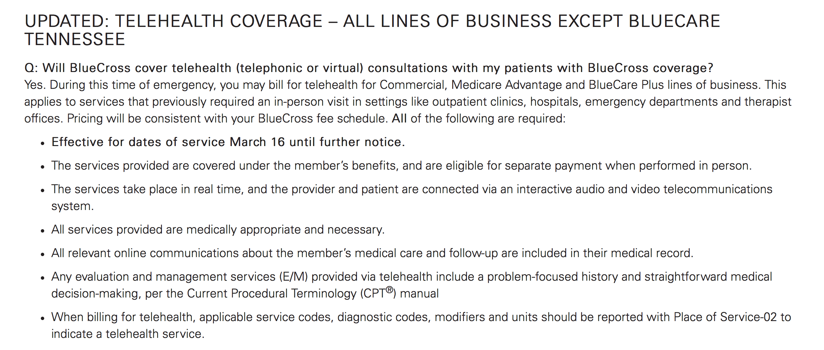
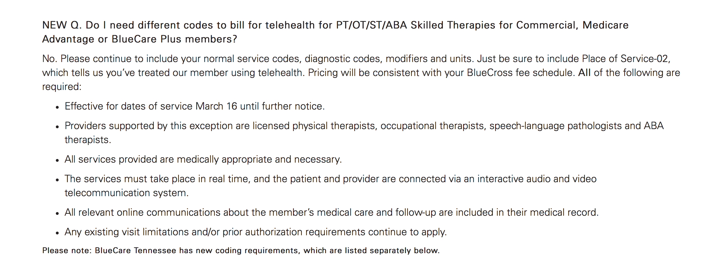

Contact BCBS
Tenncare:
As of 3/27, all Tenncare (Bluecare, Amerigroup, UHCCP) are covered through May 31.
Information obtained from: https://www.tn.gov/content/dam/tn/tenncare/documents/TennCareMCOCOVID19TelehealthDxTestingUpdate.pdf
https://www.tn.gov/content/dam/tn/finance/fa-benefits/documents/coronavirus_public_info.pdf

Tricare:
If a beneficiary meets all other criteria for a covered service for speech therapy and for continuation of PT/OT (but not initiation of PT/OT), it is covered using telemedicine, using any coding modifiers as you would for a TriCare network provider office visit
- Must be licensed in the state where care is provided and received
- HIPAA compliant platform
- Synchronous-use CPT code with a GT modifier, place of service 02
- Asynchronous- use CPT code with GQ modifier
- Pediatric home health services are covered as long as there is prior authorization for telehealth on file prior to provision of services. At this time telehealth visits are being 100% of home health rate
- Video conferencing platforms must meet requirements of HIPAA
Information obtained from: https://tricare.mil/CoveredServices/BenefitUpdates/Archives/03_24_2020_TRICARE_covers_certain_telemedicine_services
Tricare West (Health Net Federal Services)-COVID-19 and Telehealth

Contact Tricare

